Add a JAVA VM language
- Add a new res file

[ DOC from VM DOC ]

Locale String Table
Locale string table is a file containing string resources to be referred to by permission management files. A string resource file can be specified for each language. PIK configuration file MUST specify at least one locale string table.
A locale string table should be specified in a line conforming to the following format:
StringTable-index: string file name
index | StringTable-index declares an entry specifying a locale string table. index must be a string representing a value of 1 or greater. Note that this index should be used as the value to be passed in the tableId parameter to ajms_pcs_setStringTable().
string file name | The relative path to the locale string table file. Specifying this file is mandatory. For details of the format of locale string table, see Locale String Table File.
The following is an example.
StringTable-1: input/cn.res
StringTable-2: input/en.res

- 請先新增翻譯檔(.res)
請將新增的檔案放在proj\sc\application\3rd\java\Oakmont\src\data\config\permission
目前support language : Simple Chinese (cn.res) / English (en.res) / Traditional Chinese (tw.res)
EX : 新增jp.res
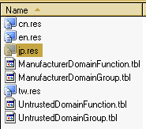

- ADD string table at PapayaPik.cfg file
Add the definition at PapayaPik.cfg on proj\sc\application\3rd\java\Oakmont\src\data\config
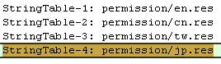

- Generate data content by gen_buildindata.bat
      - Check out 2 files: proj/sc/application/3rd/java/Oakmont/inc/kjava_sys_data_content.h proj/sc/application/3rd/java/Oakmont/src/data/kjava_sys_data_content.c
      - Exe gen_buildindata.bat at proj\sc\application\3rd\java\Oakmont\src\data\config to start generating data content :
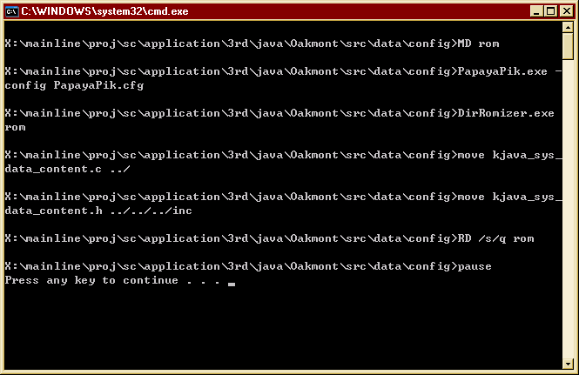

- Set Rule for the String Table
Using ajms_pcs_setStringTable(TableIndex) to set the string table.
Add the rule at jap_ven.c - jv_init_resource function at proj\sc\application\3rd\java\Oakmont\src
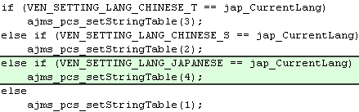
The input is the string Table index :

- build Java Oakmont solution
make clean_lib TARGET=Oakmont
./release_pmake.sh Oakmont
make release_final

Q & A
1. res檔format
請確保format為UTF-8 (在存檔前必須選擇format為UTF-8),或者請參考平台提供的三各res檔作修改,以確保其format為UTF-8, 在修改完res檔後,使用ultra-edit應該要可以看到正確的語言,而不是亂碼。

